Reproductive mechanisms underlying operation sex ratio variation in *Silene acaulis*

**Introduction**

Reproductive strategies in angiosperms are immensely diverse. Most plant species are hermaphrodite, with both female and male organs contained in one flower. Because of the close proximity of the reproductive organs, inbreeding is common in hermaphrodites. Due to inbreeding depression, mechanisms to separate the sexes commonly evolve, either by herkogamy, separation in space, dicliny, presence of unisexual flowers, or dichogamy, separation in time. Dicliny is fairly common with around 10% of angiosperms with unisexual flowers within the same plant or on different individuals, also known as dioecy.

Gynodioecy is a dioecious mating system by which individuals are either hermaphrodite or female. One common mechanism of gynodiocy is the introduction of mutations in the cytoplasmic DNA that confer male sterility. The female plants are obligate outcrossers and are more likely to escape inbreeding depression. The cytoplasmic male sterility can invade a population rapidly. However, balancing selection acts by suppressing female advantage through pollen limitation. Pollen from hermaphrodites is required for reproduction, favoring hermaphrodites. Balancing of inbreeding depression favoring females and pollen limitation favoring hermaphrodites in a population maintain the gynodioecious mating system in a population.

Gynodioecy is thought to be an intermediate state in the evolution of dioecy. Female and male function become segregated among individuals as females allocate more resources to seed production and progeny survival. The male function of hermaphrodites contributes more to the reproductive output in a population than the female function on hermaphrodite plants. Eventually, female function could be lost in favor or allocating more resources to pollen production, leading to a dioecious system. Differential selection on floral traits on the two sexes leads to dimorphic flowers.

Hermaphrodites generally have larger flowers than females due to the additional space required for pollen and anther production as well as the carpels. The resources required for producing larger flowers and male traits are often reallocated to increased seed production or superior seed provisioning in females. The style and stigmatal surface on females are also typically larger than on hermaphrodites for two reasons: stronger selection for more prominent styles and stigmas in females and reduced time for pollen receipt in hermaphrodites. First, seed production is only possible for females when pollen from a separate plant is deposited on the stigma. Female plants with a larger stigmatal area are more likely to be pollinated and produce seeds in a pollen limited environment. Second, many species that have hermaphrodite flowers are protandrous, with anthers maturing and dehiscing before the stigma of females become receptive. Sexual conflict due to the proportional length of time pollen vs the stigmatal surface is on display can impact the fitness contributions from female vs male function. Many hermaphrodite species remain in the male phase until pollen is removed from the anther. In environments with limited access to pollinators, the male phase on a flower may be long relative to the female phase. The reduced phase when the stigma is receptive before the flower senesces limits the length the style can grow and be receptive while pollinators are still visiting the flower.

Environmental factors can influence the reproductive success and potentially other vital rates of females and hermaphrodites to different extents. Often the operational sex ratio (OSR; proportion of hermaphrodites in a population) serves as a snapshot of the relative advantage for females and hermaphrodites in the recent past. Yet, the mechanisms that drive sex ratio in a population are rarely studied. Mechanisms that likely drive female vs hermaphrodite advantage are resource limitation, pollen limitation or some level of isolation, and inbreeding depression. When resources are limited, females may have the advantage in the allocation of resources to female function. Pollen limitation or the lack of pollinator access severely disadvantages females in a population. Hermaphrodites in isolated locations or with limited access to pollinators have the advantage of pollen on the same plant and flower with the potential for selfing, geitonogamously (different flowers of the same plant) or autogamously (within a flower). High rates of selfing, however, leads to inbreeding depression. The fitness of progeny produced by females that are outcrossed may be higher than those from self-fertilization, which have a higher chance of expressing deleterious, recessive alleles. While these mechanisms are theorized to affect sex ratio, few studies have explicitly observed how these mechanisms differ in populations with different sex ratios.

In this study, we explored the interplay of these mechanisms maintaining the gynodioecious mating system in the alpine and arctic tundra species, *Silene acaulis*. We compared female and hermaphrodite plants through floral morphological traits, rates of pollination, and a controlled pollination field experiment at two populations that differed in the OSR. We sought to answer the questions:

1. Is there selection on dimorphic floral traits in females and hermaphrodites, driven by agents of selection?
2. Do the site-level and micro-level sex ratios impact pollination and ultimately reproductive output?
3. What are the implications of patterns of selection for the evolutionary trajectory of this species?

We predict that selection on floral traits involved in female function is stronger in females than hermaphrodites, and particularly in populations with a low OSR. We predict that

* Hermaphrodites in populations with high OSR allocate more resources to male function.
* Hermaphrodites in populations with low OSR allocate more resources to female function
* Pre-fertilization
  + How do floral traits differ?
  + How do floral traits and sex impact pollination?
  + How does sex ratio impact pollination?
* Post-fertilization
  + How do females and hermaphrodites compare in resource allocation to seed and fruit production?
  + Are females and hermaphrodites pollen limited?
  + Does inbreeding affect fruit and seed production in hermaphrodites?
  + How does sex ratio impact seed and fruit production?

**Methods**

Study System

*Silene acaulis* is a long-lived, gynodioecious cushion plant. The squat, alpine and arctic tundra species has a distribution that is almost circumpolar, occurring throughout North America, Europe, and Eastern Russia at high elevations and latitudes. Individual plants have a single taproot with a dense, elliptical cluster of leafy rosettes. *S. acaulis* only reproduces sexually with mature plants producing a few flowers on small plants to hundreds of flowers on the largest plants. The flowering duration of a plant can extend for a few weeks as the phenology of individual flowers can vary substantially. Females and hermaphrodites vary in their morphology and when the stigma is receptive. Hermaphrodites generally have larger flowers (Shykoff, 1992) and are protandrous, meaning that the anthers mature and dehisce prior to the stigma becoming receptive.

*Silene acaulis* plants that survive to the largest size class are estimated to live up to 338 years (Morris & Doak, 1998). However, few plants, approximately 1.8% of seedlings, survive to 300 years. On average, female and hermaphrodite plants reach reproductive maturity at around 20 and 30 years respectively. In Alaska, female plants are estimated to produce 4.4 times the number of seeds as hermaphrodites throughout their lifetime (Morris & Doak, 1998). Other studies at lower latitudes annual seed production is 2 to 3 times higher in females thant hermaphrodites (Hermanutz & Innes, 1994; Shykoff, 1988). Seed number per fruit do not differ between females and hermaphrodites (Delph et al., 1999), but females do reallocate resources from pollen production to produce more flowers and fruit on a plant (Delph et al., 1999; Shykoff, 1988; Shykoff et al., 2003). Females tend to have seeds with higher establishment rates than hermaphrodites (Shykoff, 1988). However, seed provisioning does not differ between females and hermaphrodites (Delph et al., 1999), and the seed quality is not fully explained by inbreeding depression in hermaphrodites (Shykoff, 1988). Others have hypothesized that the differences in seed establishment depend on the timing or quality of pollen receipt (Shykoff, 1988, 1992), and as of yet, other unknown differences in seed quality (Delph et al., 1999; Shykoff, 1988; Shykoff et al., 2003).

Sites

We established two sites at the Niwot Ridge Long-Term Ecological Research station in Colorado. We selected sites that were surveyed for OSR the previous year (2023). OSR was surveyed by recording the sex of 200 plants along parallel transects horizontal to the slope. The East Krummholz site was at 11,348 feet in elevation, just above tree line on an east facing slope. The West Knoll site was at 11,845 ft in elevation, near the top of the ridge on a south facing slope. The OSR (proportion of hermaphrodites in the population) and 95% confidence intervals of the East Krummholz and West Knoll sites were 0.75 (0.68, 0.80) and 0.43 (0.36, 0.50) respectively.

Pre-fertilization experiment

We compared floral traits, pollen deposition, and pollen removal between female and hermaphrodites and between sites with different operational sex ratios. We marked 30 female and hermaphrodite plants in both sites. During flowering, three buds were marked the day before flowering and one bud was collected and placed in 70% ethanol for storage. Four days after the bud opened, the marked flowers were collected. We established that day four had maximum pollen deposition in a pilot study the year prior to this experiment. The anthers still attached to each collected flower were removed and placed in one microcentrifuge tube with 70% ethanol. The full pistil from each collected flower was placed in a microcentrifuge tube with 3 parts acetic acid:1 part 100% ethanol for 24 hours for fixation before the pistil was transferred to 70% ethanol following a protocol from Kearns and Inouye (1993).

Flowers on each plant were marked and collected three times during the course of this experiment, if plants were still in flower. Additional plants were added to the dataset in the East Krummholz site, because individuals that were originally marked in week one were finished flowering. Each day the plants were marked, the number of female and hermaphrodite plants within a 1-meter distance from the focal plant were recorded to obtain a micro sex ratio.

Stigmas were measured to the nearest millimeter using a ruler and the whole pistil was mounted on a microscope slide. The number of Caryophyllaceae pollen grains on each stigma and the number of ovules in the ovary were counted using a light microscope (Accu-Scope® EXI-310).

Post-fertilization experiment

We used a pollination experiment to compare the reproductive success of female and hermaphrodite plants. We marked 30 female and 30 hermaphrodite *S. acaulis* plants at the West Knoll and the East Krummholz sites. The pollination experiment had four crossing treatments for hermaphrodites (no pollen, open pollinated, outcrossed, and selfed) and three from females (all treatments except selfed). To apply the treatments, we selected four (or three) buds that would open the next day. For the open pollination treatment, we marked one bud by placing a dot on the calyx with an oil-based marker and by inserting a colored toothpick near the bud. No other manipulation was applied for the open pollination treatment. For the three other treatments, we covered buds with a pollinator exclusion contraption fashioned from a cut microcentrifuge tube and mesh. The exclusion contraptions were marked with different colors to designate the separate treatments. No other manipulation was applied to the no pollen treatment. Three days later, manual pollination by pressing the anthers of one flower against the stigma of the focal flower was used to apply the outcrossed and selfed treatments. For the outcrossed treatment, 2 flowers from 2 plants at least 10 meters away were collected and used for the pollination. For the selfed treatment on hermaphrodites only, two flowers were collected from the same plant as the focal flower and used for the pollination. The pollinator exclusion contraptions were replaced over the flowers and left until the flowers developed into fruit. Three weeks later, the fruit or remnant, unfertilized flowers from each treatment were collected. Fruit set, seed number, total seed mass per fruit, and seed viability were recorded. We determined seed viability by whether the seeds germinated in a germination trial or not.

***Figure XX.*** *(A) Crossing treatments on the plants with transparent circles indicating pollinator exclusion contraptions. (B) Predicted outcomes for viable seed number for the crossing treatments.*

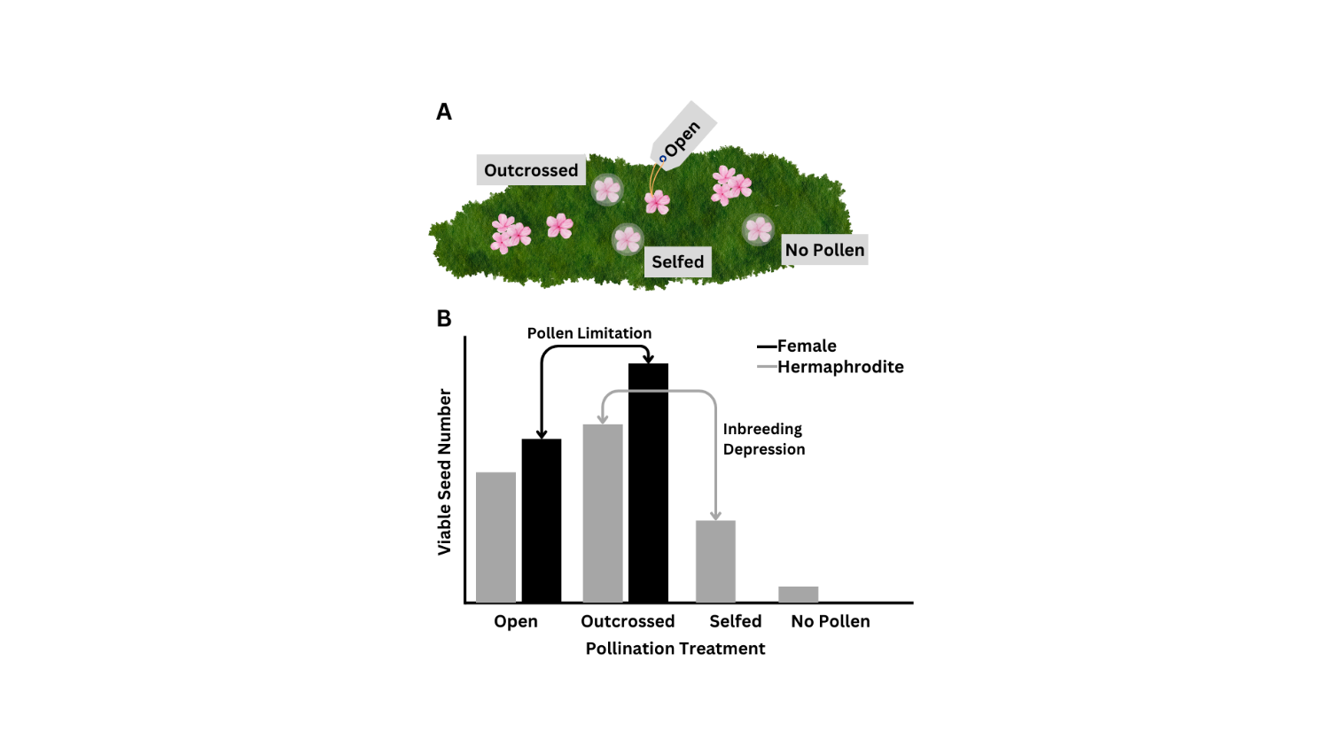

Analysis

*Pre-fertilization*

Floral traits, such as stigma length and ovule number, were analyzed using mixed effects models with the general structure of sex, site, and the interaction between sex and site as fixed effects, and individual plant ID as the random effect. Stigma length was modeled using a linear regression (lmer, *lme4*; Bates et al. 2015). Due to our interest in the presence of female function and an excess of ovaries with no ovules in our dataset, we used a hurdle model approach for ovule number. Female function was modeled as a binary (with ovules, without ovules) using a generalized mixed effects model with a binomial distribution (glmer, *lme4*). Ovule number, given female function, was modeled using a generalized mixed effects model with a Poisson distribution (glmer, *lme4*).

To test the effect of floral traits and micro sex ratio on pollination, we modeled the pollen count as the binary variable, pollen deposition (pollen deposition, no pollen deposition) and pollen count, given pollen was deposited on the stigma. The general structure for the model included the fixed effects stigma length, micro sex ratio, sex, and site, and the three-way interactions with sex, site and stigma length or micro sex ratio. Plant ID was a random effect in the model. Pollen deposition was modeled using a negative binomial generalized mixed effects model (glmer.nb, *lme4*) and pollen number using a generalized mixed effects model with a Poisson distribution (glmer, *lme4*).

*Post-fertilization*

Fruit set, seed number, seed germination rate, and the cumulative reproductive output were analyzed using generalized linear models. The cumulative reproductive output was calculated by multiplying the fruit set (0,1) by the seed number and germination rate (proportion of seeds from a fruit that germinated). The general model structure included the fixed effects sex, treatment, site, and the interactions between all predictors. Fruit set and the probability that seeds germinated were analyzed using a binomial distribution. Seed number and cumulative reproductive output were analyzed with a Poisson distribution.

All analyses were performed in R 4.4.1.

**Results**

***Pre-fertilization***

*How do floral traits differ between sexes and individuals?*

Females have stigmas that are 1.33 mm longer on average than hermaphrodite stigmas (χ2=46.523, p<0.001). The stigma lengths did not differ across the two populations (χ2=1.411, p=0.235). Individual plants varied in the stigma lengths (χ2=31.866, p<0.001).

The likelihood of producing ovules did not depend on sex (χ2=1.049, p=0.306), but plants from the East Krummholz site were more likely to produce ovules than individuals from the West Knoll site (χ2=6.134, p=0.013). We found that the likelihood of producing ovules was related to stigma length (χ2=43.647, p<0.001). Individuals varied in the mean likelihood of ovule production (χ2=11.592, p<0.001). The interactions between population and stigma length (χ2=9.249, p=0.002) and population and sex (χ2=4.621, p=0.032) were also significant. Some hermaphrodite plants in both populations were functionally male and did not develop ovules in the flowers sampled. One female plant developed no ovules in the two flowers sampled. In flowers with ovules, there were no differences in the number of ovules between the two sexes (χ2<0.001, p=0.984), with increasing stigma length (χ2=1.703, p=0.192), and between the two sites (χ2=0.117, p=0.733).

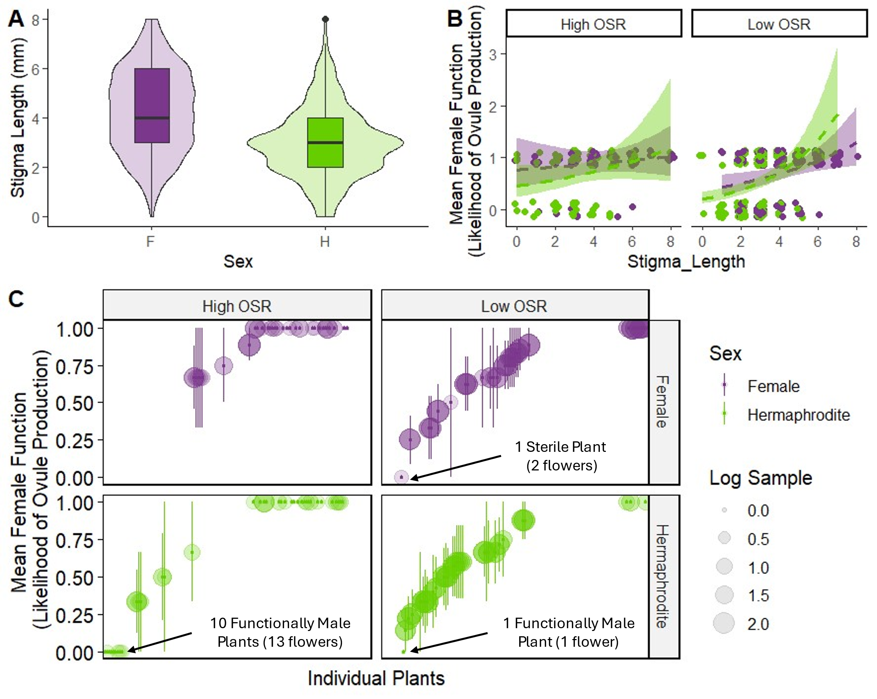

Figure XX. Plant traits in females and hermaphrodites from the East Krummholz and West Knoll sites. Box plot of stigma length (A) showing the median and violin overlay with the density. Average female function, or likelihood of ovule production (B), with error bars showing the standard error. Female function of individual plants (C) with points indicating the mean female function, error bars indicating the standard error, and bubbles indicating the sample size for each individual.

*How do floral traits and micro sex ratio affect pollination?*

The likelihood of receiving pollen depended on the stigma length (χ2=46.666, p<0.001), sex (χ2=20.783, p<0.001), micro sex ratio (χ2=7.414, p=0.006) and the interactions between stigma length and sex (χ2=9635, p=0.002) and population and sex (χ2=5.218, p=0.022). The interaction between stigma length and population was marginally significant (χ2=3.031, p=0.082).

Given that pollen was deposited on the stigma, pollen number depended on stigma length (χ2=18.197, p<0.001), sex (χ2=4.407, p=0.036), and marginally on population (χ2=2.862, p=0.091). The interaction between stigma length and sex (χ2=10.773, p=0.001) and the three-way interaction between stigma length, sex, and population (χ2=4.359, p=0.037) were also significant.

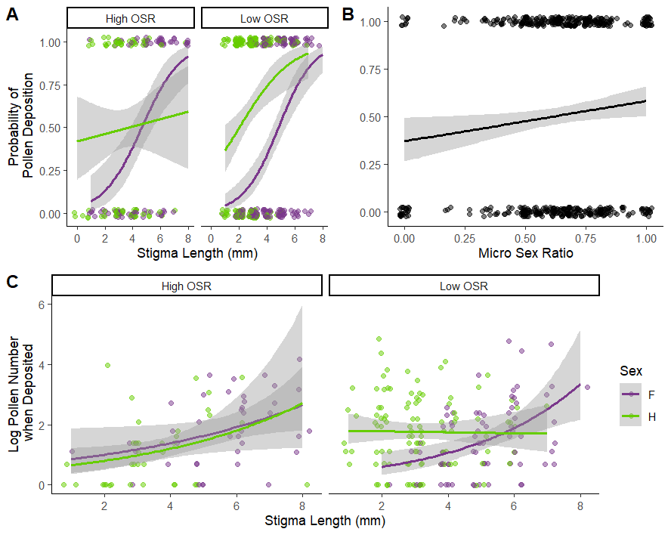

Figure XX. The likelihood of pollen deposition as stigma length (A) and micro sex ratio (B) increase. Given that pollen was deposited on the stigma, the pollen number as stigma length increases (C).

***Post-fertilization***

Fruit

The production of fruit was determined by sex (χ2=9.452, p=0.002), treatment (χ2=113.730, p<0.001), and the interaction between sex and treatment (χ2=14.317, p<0.001). Population was marginally significant (χ2=2.847, p=0.091). Flowers that were outcrossed were most likely to develop fruits in both sexes. However, females had a higher proportion of fruit set than hermaphrodites (Tukey Post-Hoc p<0.001). Females and hermaphrodites did not differ in the open pollinated treatment.

Seeds

The number of seeds produced depended on treatment (χ2=51.355, p<0.001). The interactions between sex and population (χ2=85.291, p<0.001) and treatment and population (χ2=31.618, p<0.001) were statistically significant.

Germination

The probability of germinating depended on sex (χ2=14.139, p<0.001), treatment (χ2=100.840, p<0.001), and site (χ2=31.083, p<0.001). The interactions between sex and treatment (χ2=6.166, p=0.046) sex and site (χ2=61.853, p<0.001), and treatment and population (χ2=22.545, p<0.001) were all significant.

Cumulative Reproductive Output

The cumulative reproductive output (number of viable seeds produced) depended on the treatment (χ2=136.179, p<0.001) and population (χ2=9.658, p=0.002). The interactions between sex and treatment (χ2=7.938, p=0.019), sex and population (χ2=162.211, p<0.001), and treatment and population (χ2=37.660, p<0.001) were also significant.

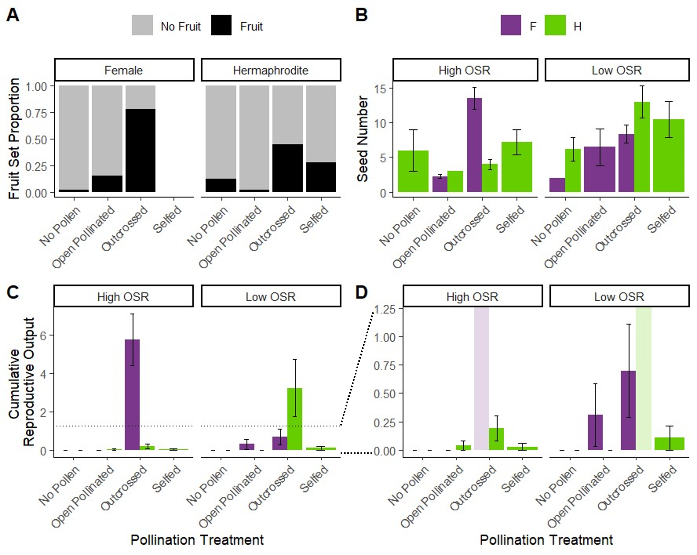

Table XX. Post-hoc comparisons of fruit production by treatment and sex. A Tukey test was used to determine significance.

|  |  |  |  |  |  |  |  |  |
| --- | --- | --- | --- | --- | --- | --- | --- | --- |
|  | **Fruit Set** | | **Seed Number** | | **Germination Rate** | | **Total Reproductive Output** | |
| **Treatment** | **Odds Ratio** | **p-value** | **Odds Ratio** | **p-value** | **Odds Ratio** | **p-value** | **Odds Ratio** | **p-value** |
| **No Pollen** | 6930 | 0.989 |  |  |  |  |  |  |
| **Open Pollinated** | 0.000 | 0.988 |  |  |  |  |  |  |
| **Outcrossed** | 0.224 | **<0.001** |  |  |  |  |  |  |
| **Selfed** | na | na |  |  |  |  |  |  |

Table XX. Mean and standard deviation of seed production for the outcrossed and open treatment of the pollination treatment for the two populations (high and low OSR) and two sexes (female and hermaphrodite). Pollen limitation is a calculated value describing the pollen limitation from the seed production of the outcrossed and open treatment.

|  |  |  |  |  |  |  |
| --- | --- | --- | --- | --- | --- | --- |
| **Population** | **Sex** | **Outcrossed** | | **Open** | | **Pollen Limitation** |
| **Mean** | **SD** | **Mean** | **SD** |
| High OSR | Female | 10.5 | 8.57 | 0.375 | 0.875 | 3.34 |
| High OSR | Hermaphrodite | 1.58 | 2.50 | 0.125 | 0.612 | 2.54 |
| Low OSR | Female | 6.29 | 6.41 | 0.929 | 2.92 | 1.91 |
| Low OSR | Hermaphrodite | 7 | 9.61 | 0 | 0 | Inf |

**Discussion**

We compared the floral morphology, pollen deposition, and reproductive output for hermaphrodites and females in one low OSR population and one high OSR population in *Silene acaulis*. We found that morphological selective pressures differ for females and hermaphrodites depending on the sex ratio of the site. At the two sites included in this study, pollinators or pollination success is severely limited in both hermaphrodites and females. We found no evidence of frequency dependent selection in the low OSR population. Females were actually less pollen limited in the low OSR population than in the high OSR population.

*Selection for Sexual Dimorphism*

Similar to other studies, we found that stigma length was generally longer in females than hermaphrodites (

We had mixed results for the effect of sex ratio on pollination.

Dimorphic floral traits, particularly in female function suggest the potential that *Silene acaulis* in the Colorado Rocky Mountains may be transitioning to a trioecious mating system.

1. Is there selection on dimorphic floral traits in females and hermaphrodites, driven by agents of selection?
2. Do the site-level and micro-level sex ratios impact pollination and ultimately reproductive output?
3. What are the implications of patterns of selection for the evolutionary trajectory of this species?

Key Results

*Pre-fertilization*

1. Stronger selection for longer stigmas in females
2. Selection for longer stigmas (female resource allocation) in both sexes when pollen is limited
   1. Is b. true when pollen number does not depend on stigma length?
   2. Female stigmas are longer than hermaphrodites and as the stigma length increases, pollen deposition on the stigma increases likelihood and number. When there are fewer hermaphrodites in a population, the likelihood of pollen deposition also increases with stigma length in hermaphrodites, but the number of pollen grains is not affected.
3. Hermaphrodites may be functionally male or at least produce a proportion of flowers that are functionally male and this is more likely when hermaphrodites are more common.
4. More resources are allocated to female function when there are more hermaphrodites in a population and potentially less pollen limitation. (rephrase)
   1. The likelihood of producing ovules is higher in females than hermaphrodites. Both sexes have a higher likelihood of producing ovules in the high OSR population. Hermaphrodite individuals had a higher likelihood of producing multiple flowers with no ovules.
   2. Both sexes vary in female function
      1. Both female and males produce flowers without ovules
5. Chances of pollination for either sex increases as the number of nearby hermaphrodites increases.
6. Hermaphrodites have a pollen availability advantage in pollen limited (low hermaphrodite) environments.
   1. The likelihood of pollen deposition increased as the number of hermaphrodite plants surrounding the focal plant increased. Hermaphrodites had a higher chance of having pollen deposited on stigmas in the low OSR population, while females had a slightly higher chance in the high OSR population.

*Post-fertilization*

1. Hermaphrodites and females are pollen limited in both high and low OSR populations.
   1. The open pollinated treatment rarely produced seeds and the germination rates for those seeds were low.
2. Reproductive output depends on the sex ratio of the population.
   1. Females have a higher reproductive output in high OSR populations, but the opposite is true for low OSR populations, when pollen was supplemented.
3. Inbreeding depression affects the reproductive output of hermaphrodites.
   1. While hermaphrodites that are geitonogamously pollinated produce as many or more seeds, the germination rate is low. The same is true for seeds that were fertilized from pollen on the same flower or autogamous pollinated.

Bates, D., Maechler, M., Bolker, B., and Walker, S. 2015. Fitting Linear Mixed-Effects Models Using lme4. Journal of Statistical Software **67**(1): 1-48. doi:10.18637/jss.v067.i01.